**Amar Gajanan Mohite**

Section – IFT562

**Arizona State University**

Instructor**:** Daniel Wells

**Activity 8- Work with Amazon S3**

Date – 02/18/2024

At the end of Task 2, run the aws s3 ls command, enter your full name in the command prompt, and take a screenshot.

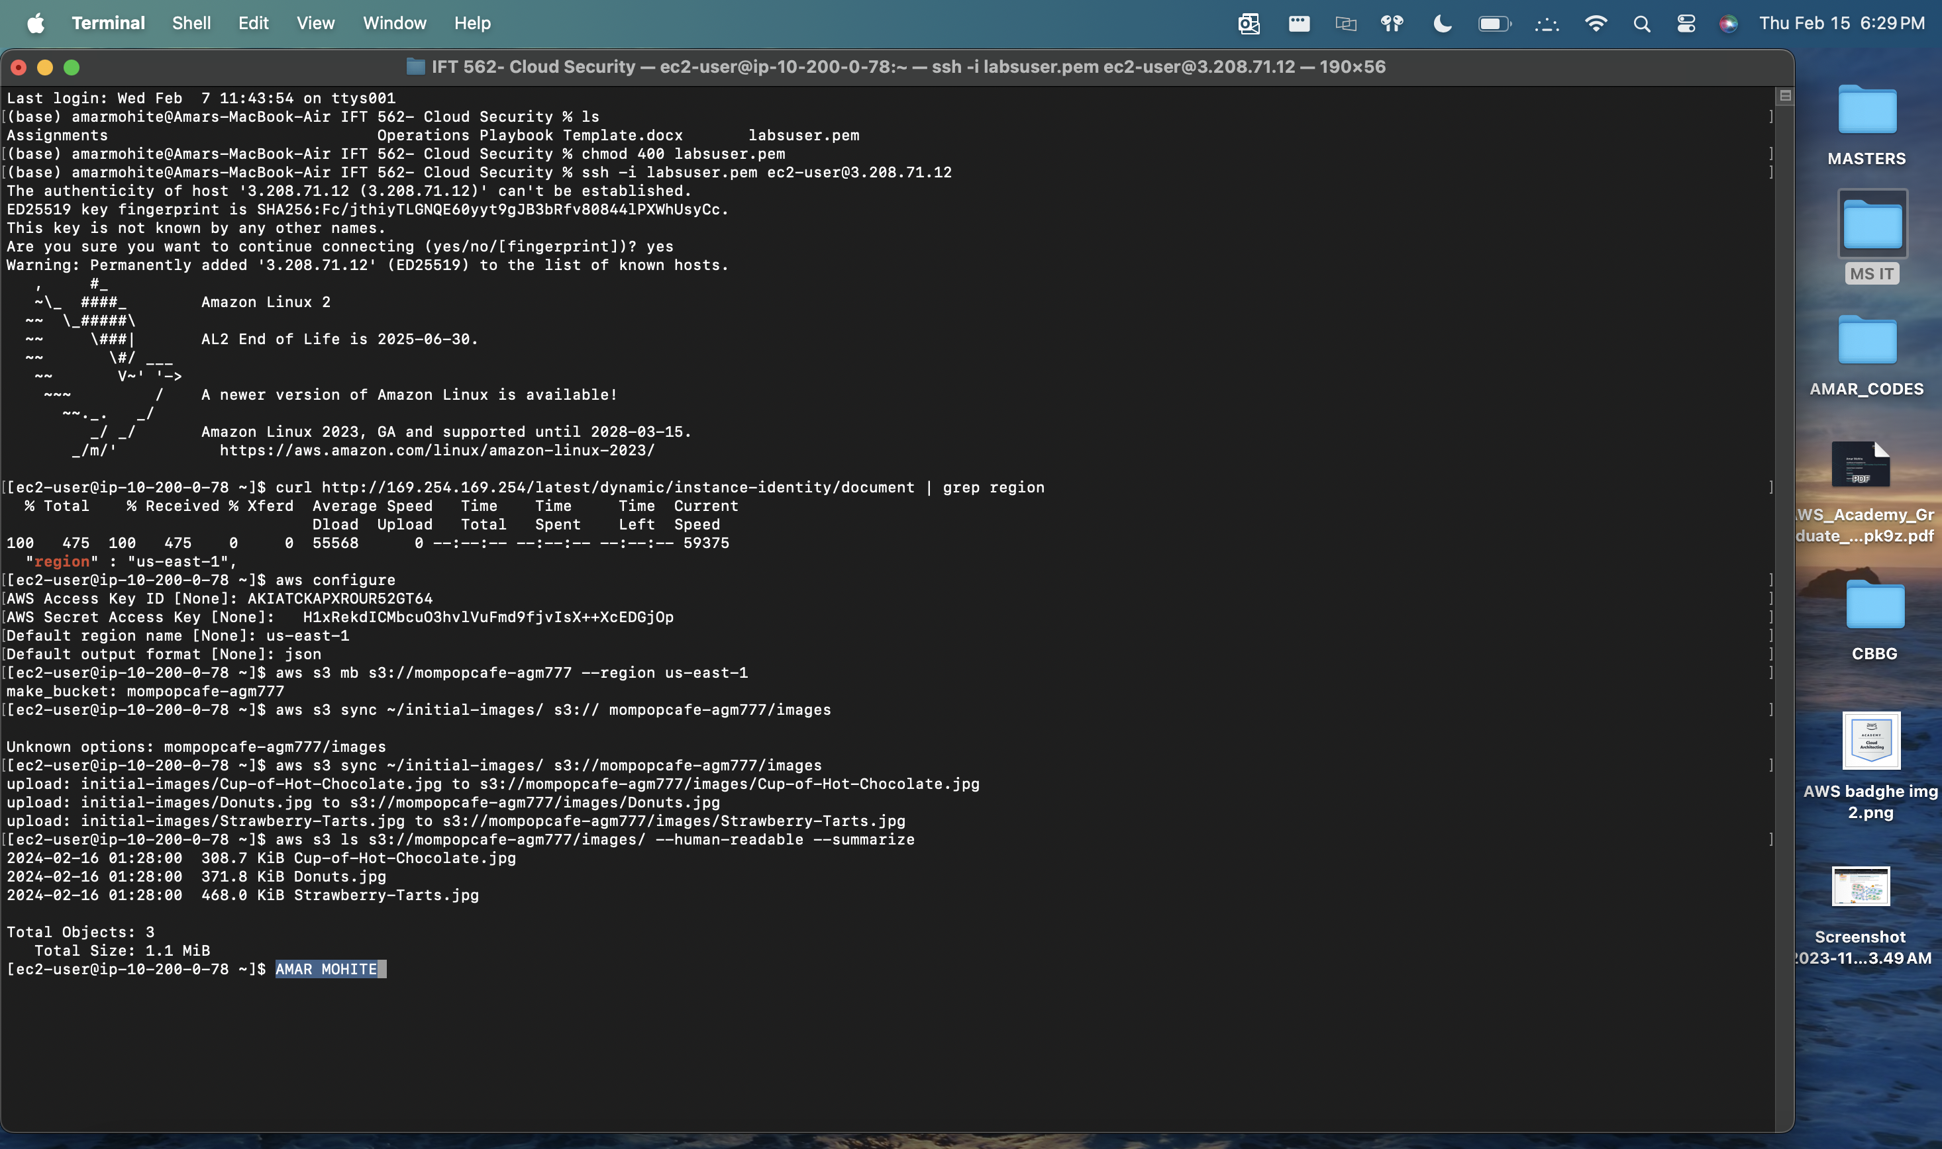

Near the end of Task 3 you should be see an error message related to bucket permissions.  Take a screenshot of the page making sure that the logged in user is visible in the top right corner.

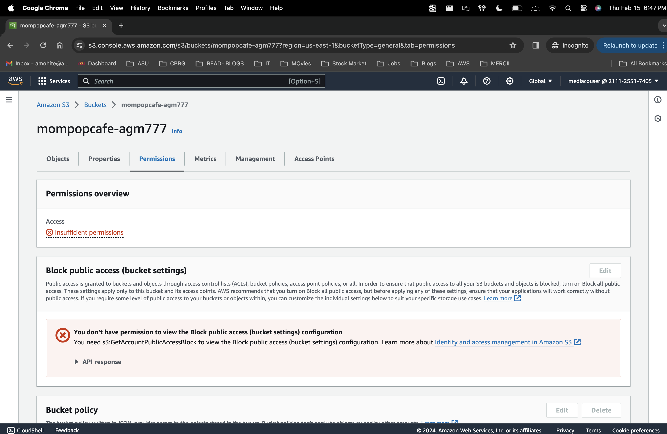

At the end of Task 4 you receive an e-mail.  Take a screenshot of that e-mail ensuring that your e-mail address is visible.

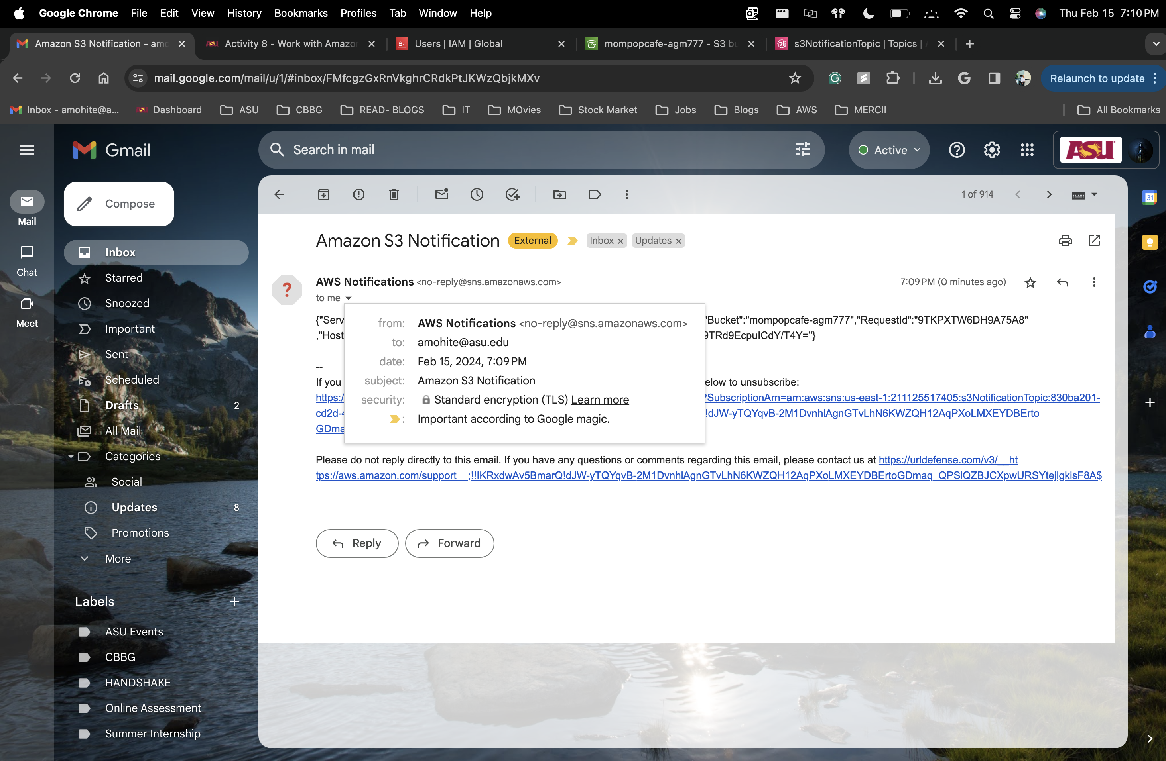

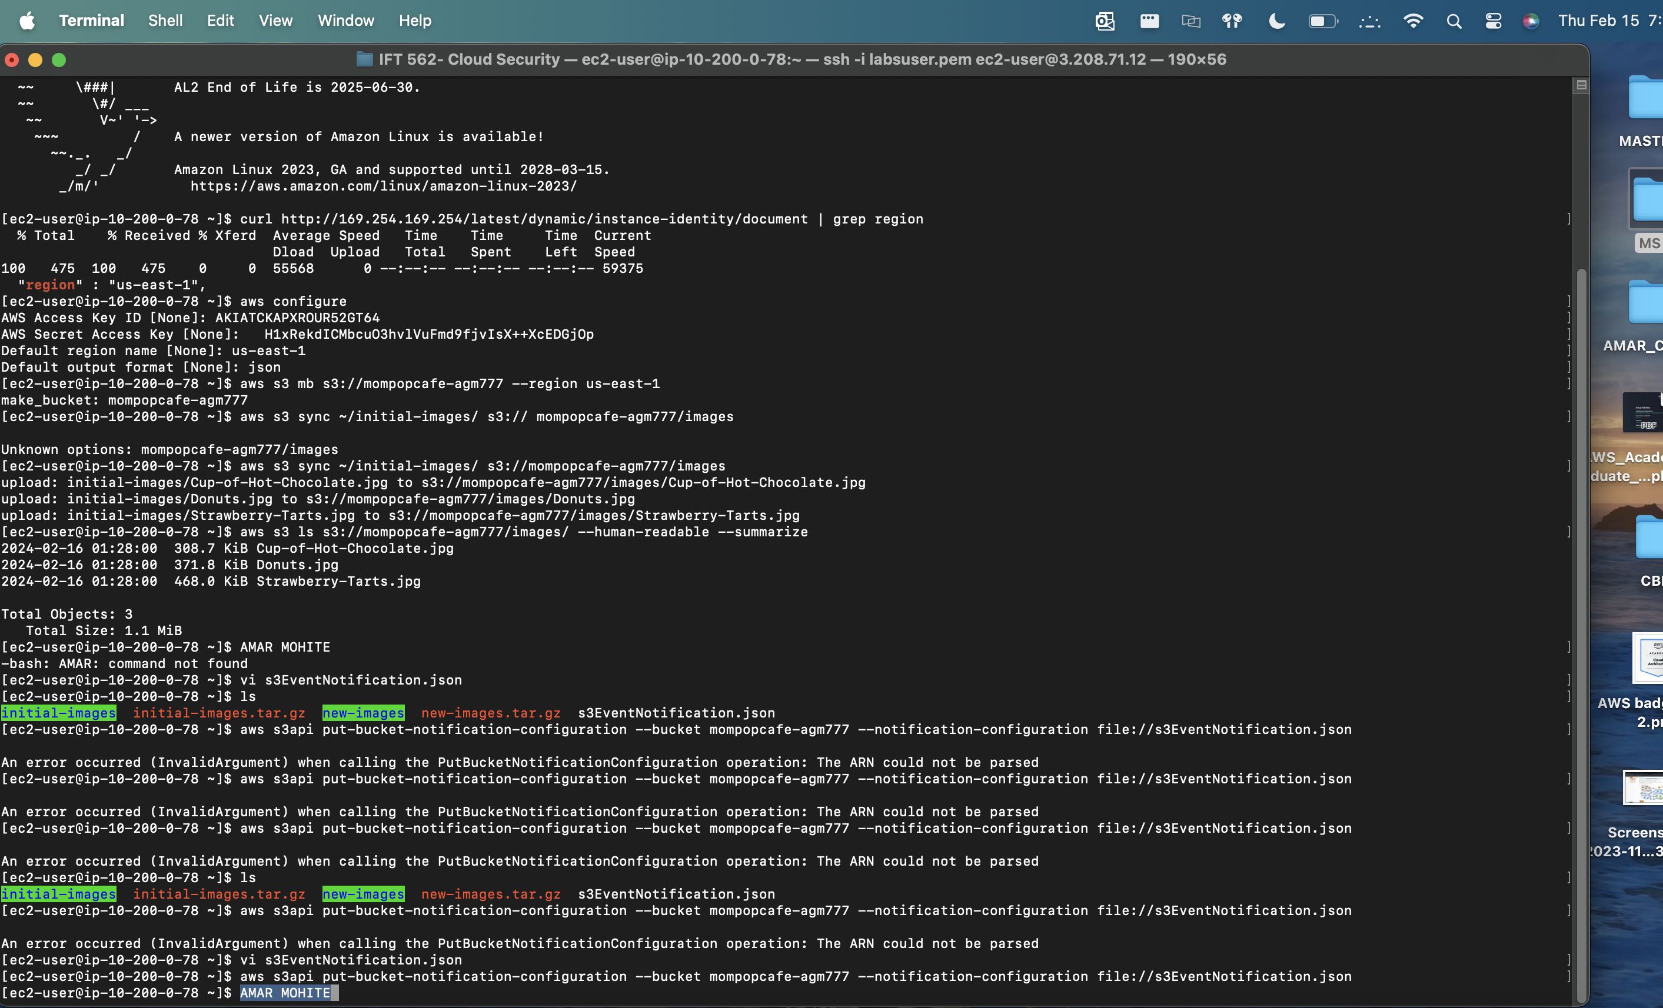

At the end of Task 5, run the aws s3api put-object-acl command, enter your full name in the command prompt, and take a screenshot.

